**Project Design Phase**

**Solution Architecture**

| Date | 26 June 2025 |
| --- | --- |
| Team ID | LTVIP2025TMID32174 |
| Project Name | EduTutor AI: Personalized Learning with Generative AI and LMS Integration |
| Maximum Marks | 4 Marks |

**Solution Architecture:**

Solution architecture is a complex process – with many sub-processes – that bridges the gap between business problems and technology solutions. Its goals are to:

* The EduTutor AI platform follows a modular, layered architecture designed for simplicity, scalability, and real-time interaction. At the presentation layer, it uses a Gradio-based UI that offers a user-friendly tabbed interface for login, course sync, quiz generation, answer evaluation, and performance review.
* The application logic is built entirely in Python and handles core functionalities like user session management, quiz history tracking, and performance evaluation. IBM Granite's large language model is integrated through Hugging Face Transformers, enabling dynamic quiz generation based on subject prompts.
* The platform runs in lightweight environments such as Google Colab or local machines and stores session data in-memory for simplicity.

**Example - Solution Architecture Diagram:**

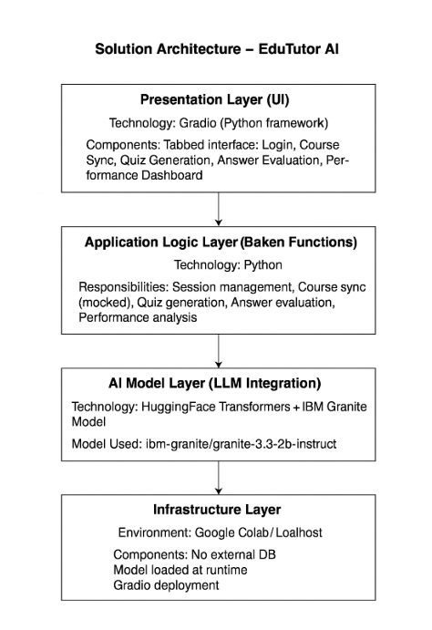

*Figure 1: Architecture and data flow*